**FINANCIAL GRANT MANAGEMENT SYSTEM**

Software Requirements Specification



Submitted by –

Rajat Babel ( B15CS028 )

Indra Kumar Malav ( B15CS020 )

|  |  |
| --- | --- |
| Financial Grant Management System | Version: <3.0> |
| Software Requirements Specification | Date: < 28- 02 -2017> |
| Updated SRS after coding | |

Revision History

|  |  |  |  |
| --- | --- | --- | --- |
| **Date** | **Version** | **Description** | **People** |
| 16 Jan 2017 | 1.0 | First Draft | Rajat Babel and  Indra Kumar Malav |
| 1 Feb 2017 | 2.0 | UML Diagrams are Added | Rajat Babel and  Indra Kumar Malav |
| 28 Feb 2017 | 3.0 | SRS is updated after coding | Backend – Rajat Babel  Frontend – Indra Malav |

|  |  |
| --- | --- |
| Financial Grant Management System | Version: <3.0> |
| Software Requirements Specification | Date: < 28- 02 -2017> |
| Updated SRS after coding | |

Table of Contents

1. Introduction
   1. Purpose
   2. Scope
   3. Constraints
   4. Assumptions and Dependencies
   5. Definitions, Acronyms and Abbreviations
   6. References
2. Overall Description
   1. Product Functions
      1. Functional Requirements
         1. Use Case Diagrams
         2. Class Diagrams
         3. Sequence Diagrams
         4. Activity Diagrams
      2. Non Functional Requirements
   2. User Characteristics
3. Specific Requirements
   1. Use Case Description
      1. Login
      2. Request Grant
      3. View Grant
      4. Delete Grant
      5. Print Document
      6. Verify Pending Request
      7. View Old Grants
      8. Remove Applicant
      9. Grant Money

|  |  |
| --- | --- |
| Financial Grant Management System | Version: <3.0> |
| Software Requirements Specification | Date: < 28- 02 -2017> |
| Updated SRS after coding | |

1 Introduction

1.1 Purpose

* To manage records of different types of grants provided by institute.
* It will reduce paper work and time.
* It will make the system transparent and less corrupt.
* It will make the process secure and efficient.

1.2 Scope

There will be 2 kinds of users.

* Admin
* Applicant ( Faculty, Ph.D. , M.Tech. , M.Sc. , B.Tech. )

Role of Admin - He has control on the whole database. He has the power of approving / disapproving grants by verifying all the documents and details.

Role of Applicant - The user can log in using his own credentials and access his past grant requests ( approved or disapproved ). The limit of grant will depend on user.

Type of grants

* Research grant.
* Travelling expenses.
* Conference expenses.
* Medical Allowances.

1.3 Constraints

* People with valid credentials can only access this software.
* A user has access to his own database only.
* A user cannot edit his grant, but only delete it.
* No one can edit a request grant, once it is saved.
* The software will work only on computer system only.

|  |  |
| --- | --- |
| Financial Grant Management System | Version: <3.0> |
| Software Requirements Specification | Date: < 28- 02 -2017> |
| Updated SRS after coding | |

1.4 Assumptions and Dependencies

* Only admin has authority to approve/disapprove a grant.
* Admin checks all the documents correctly.
* We will have credentials of all users.
* The limit of grant is already fixed for all applicants.
* User has browser installed in his system and internet is connected.
* The software works well only in large screen ( 15.6 ).
* Applicant is a part of the institute
* User knows the language ( English )

1.5 Definitions, Acronyms and Abbreviations

|  |  |
| --- | --- |
| Terms | Definitions |
| Admin | The person who has all the authority. |
| Valid credentials | Registered credentials of applicants in database |
| Applicant | Faculty , Ph.D , M.Tech. , M.Sc. , B.Tech. , the people who can request for grant |
| Database | Where all the information will be stored in a secured and organised manner |
| Pending grant | Grant requests which are yet to be approved |
| Disapproved grant | Grant requests which are disapproved by admin |
| Approved grant | Grant which are approved by admin |
|  |  |
| Research Grant | Grant provided by institute for research work to the institute person |
| Travelling Expenses | Grant given for the travel expenses to the institute person |
| Conference Expenses | Grant given for conference expenses. Ex. Hotel bills |
| Medical Allowances | Grant given to the institute person for his/her medical expenses |

1.6 References

* IEEE. IEEE Std. 830-1998 IEEE Recommended Practice for Software Requirements
* Specifications. IEEE Computer Society, 1998.

|  |  |
| --- | --- |
| Financial Grant Management System | Version: <3.0> |
| Software Requirements Specification | Date: < 28- 02 -2017> |
| Updated SRS after coding | |

2 Overall Description

2.1 Product Functions

2.1.1 Functional Requirements

* Functions for Applicants
  1. Request Grant
  2. View Grants
  3. Delete Grant
* Functions for Admin
  1. Verify Pending Grants
  2. Remove Applicant
  3. View Old Grants
  4. Grant Money
  5. Validate Grants

2.1.1.1 Use Case Diagrams

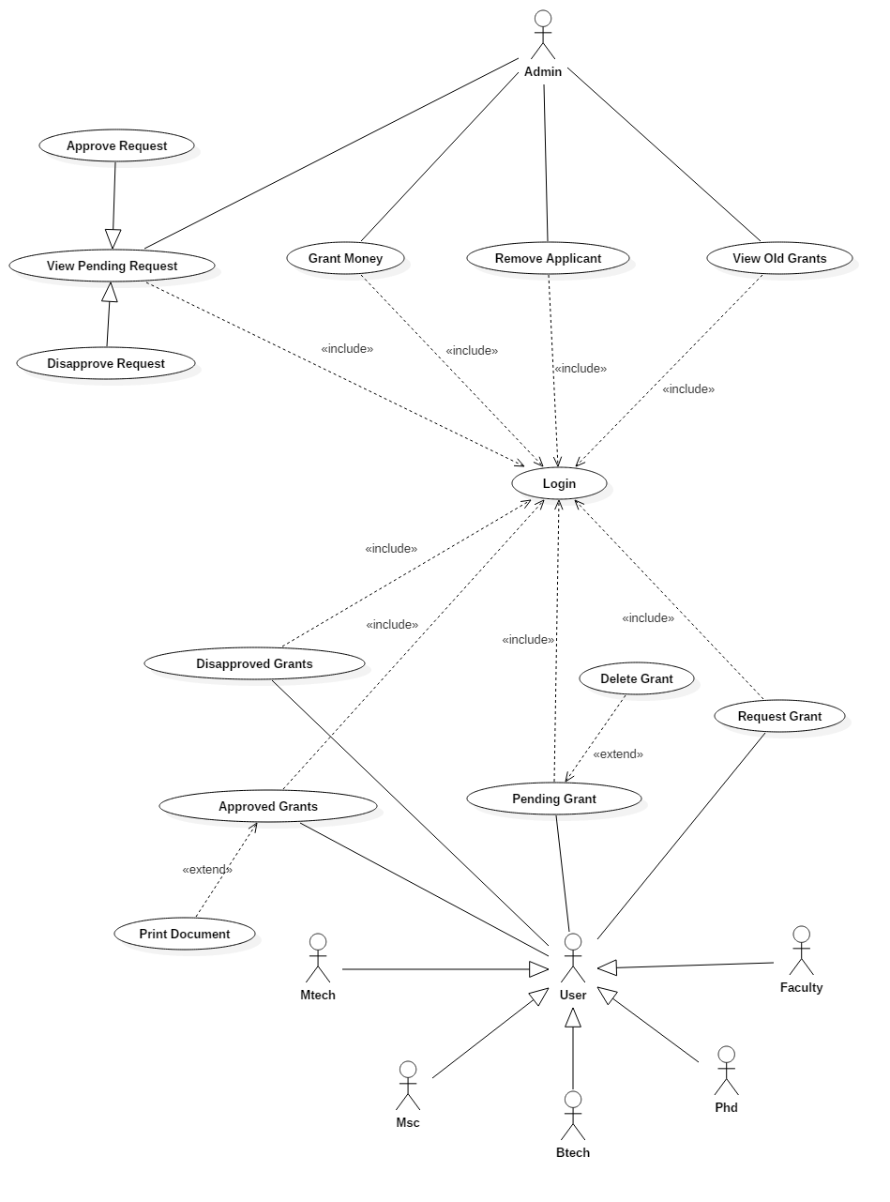

2.1.1.2 Class Diagram(s)

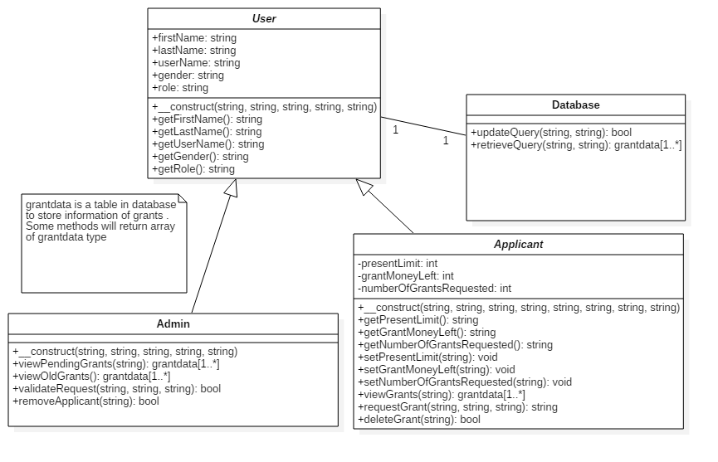

2.1.1.3 Sequence Diagram(s)

1) Login

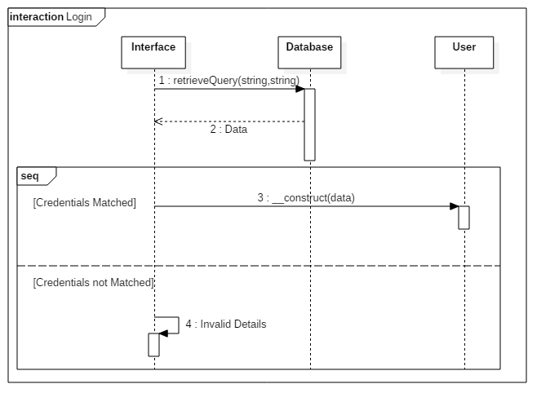

2) Request Grant

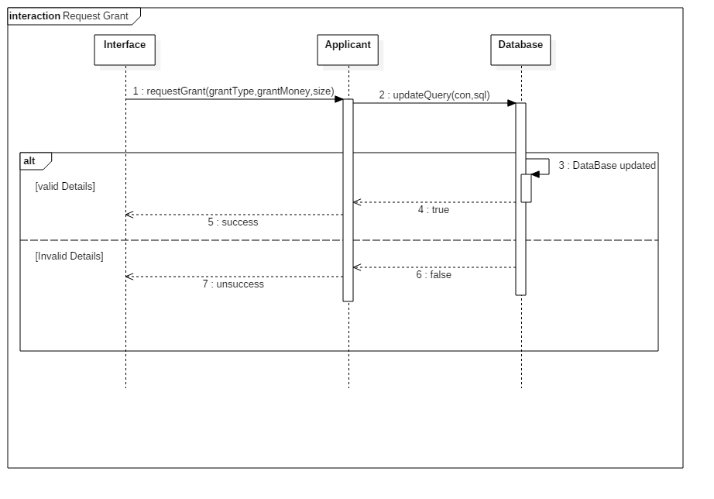

3) Validate Grant

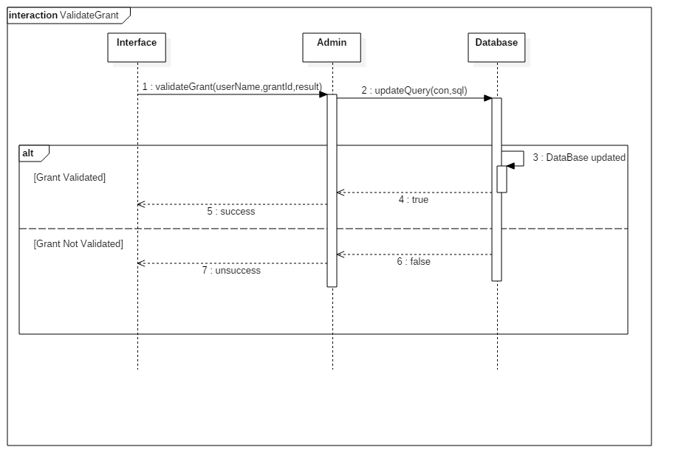

4) Delete Grant

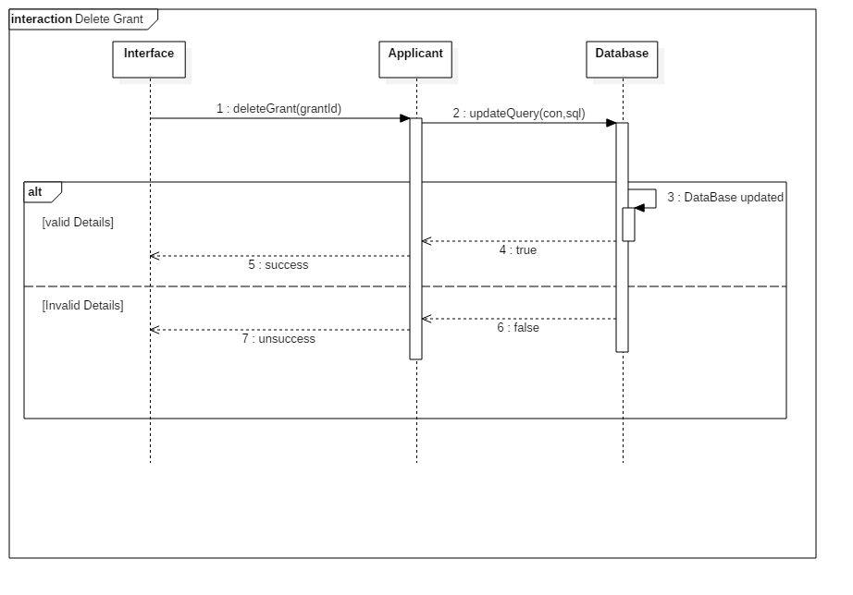

5) Print Document

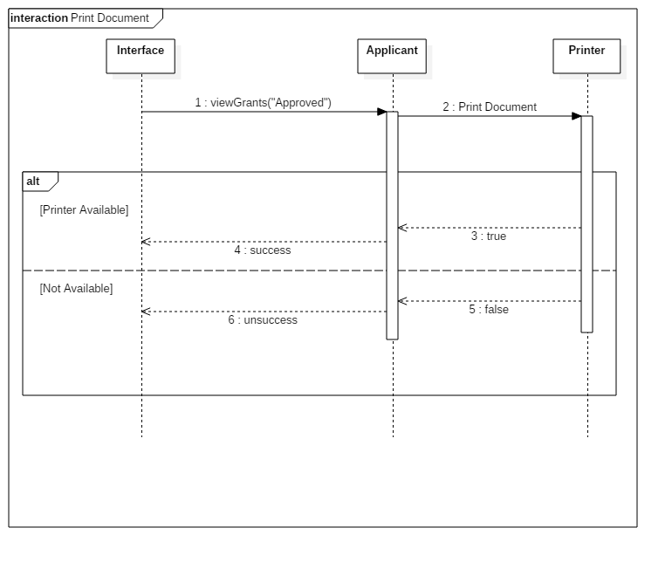

6) Remove Applicant

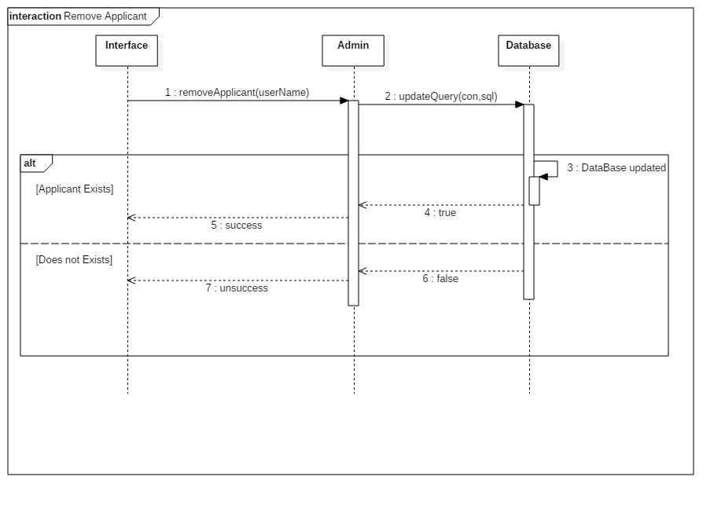

7) View Old Grants

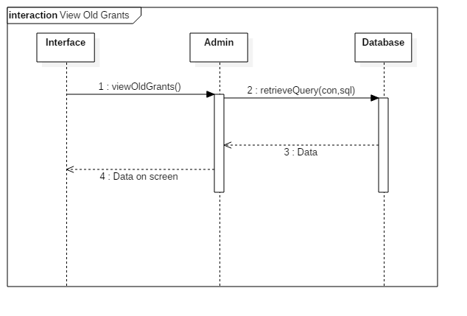

8) View Grants

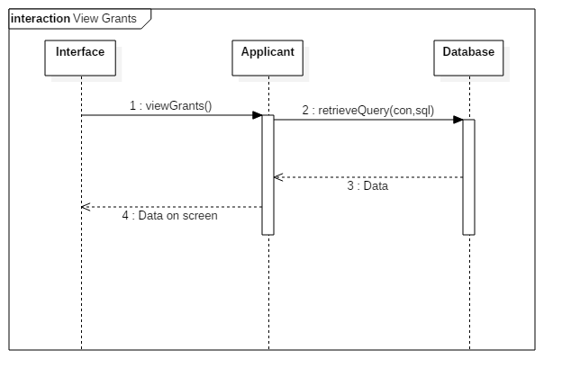

9) Grant Money

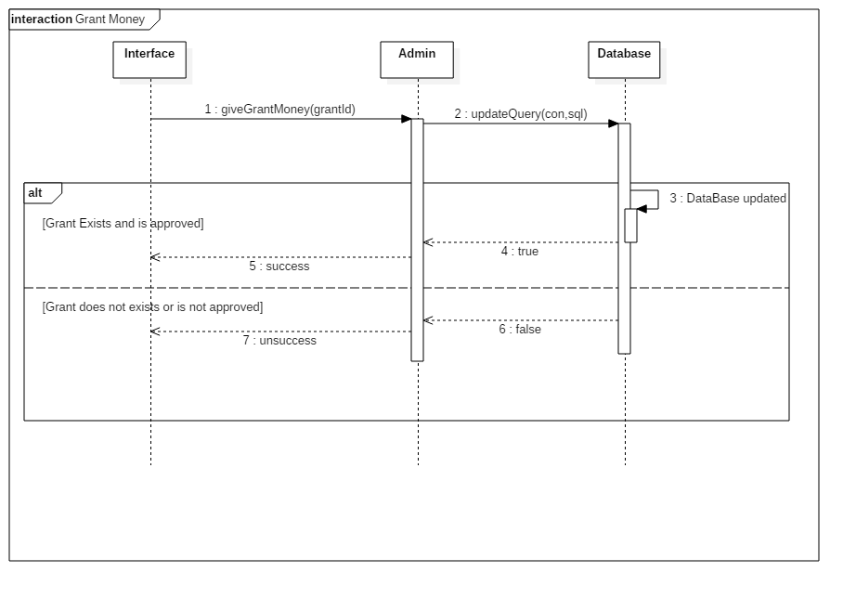

2.1.1.4 Activity Diagram(s)

1) Login Activity

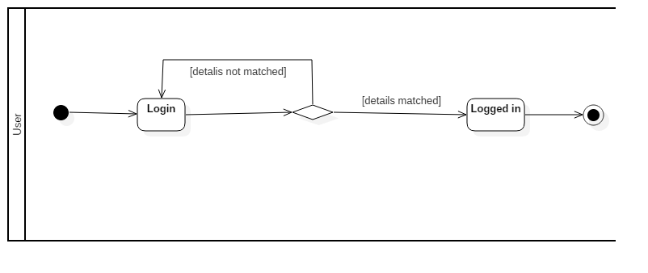

2) Request Grant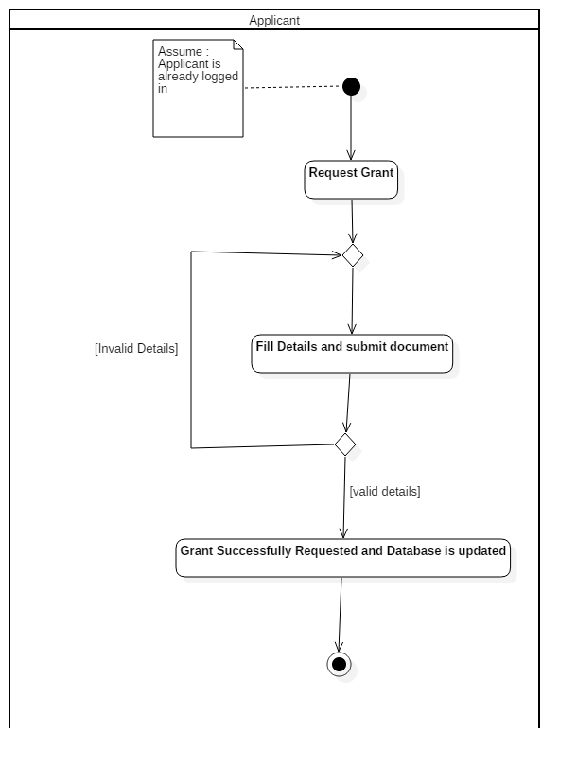

3) View Grants

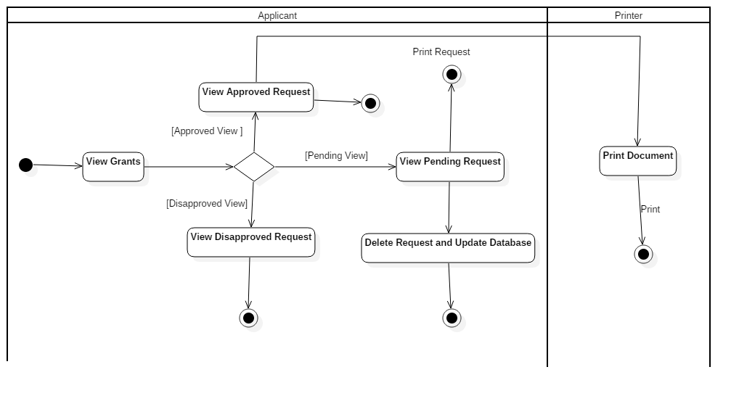

4) View Pending Grants

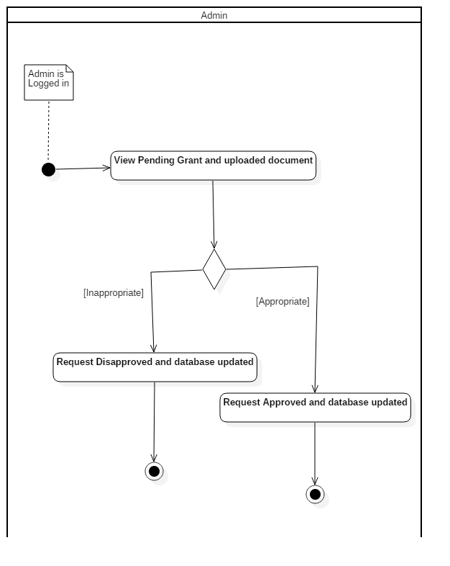

5) Grant Money

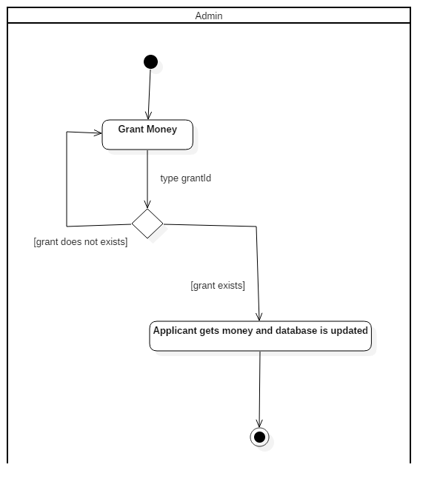

6) Remove Applicant

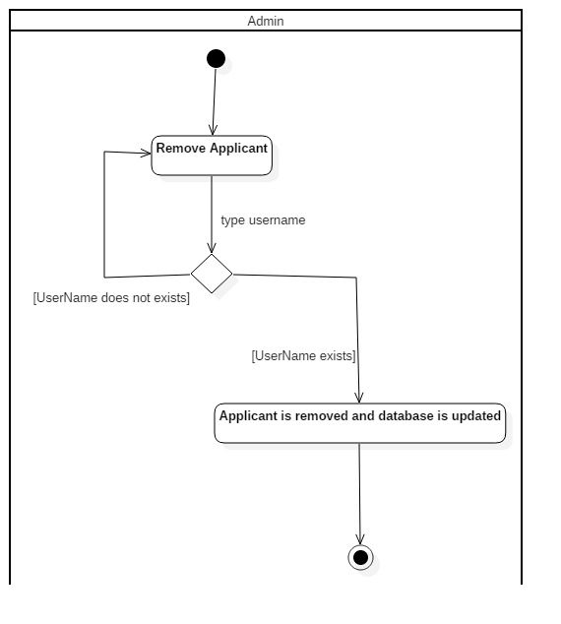

2.1.2 Non - Functional Requirements

* Scalability
* Capacity
* Availability
* Reliability
* Recoverability
* Maintainability
* Serviceability
* Performance

2.2 User Characteristics

User should be a member of institute and have basic knowledge of English.

3 Specific Requirements

3.1 Use case description

3.1.1 Login:

|  |  |
| --- | --- |
| Name: | Login |
| Short Description: | The user can log in to the software |
| Precondition: | Login page is open |
| Post Condition: | The user is logged in and can do his work |
| Error situation(s): | The user might not have an account |
| System state in the event of an error: | The user is not logged in |
| Actor(s): | User |
| Trigger: | User wants to do so work and he opens the website |
| Standard process: | 1). User enters the credentials and role.  2). System confirms that the credentials and role are correct.  3). User is logged in. |
| Alternate process: | Not any |

3.1.2 Request Grant:

|  |  |
| --- | --- |
| Name: | Request Grant |
| Short Description: | The applicant can fill the form to request for a grant |
| Precondition: | The applicant must be logged in |
| Post Condition: | The request is saved in the database and sent to admin |
| Error situation(s): | He has no balance in his account to request for the grant |
| System state in the event of an error: | The applicant has not requested for the grant |
| Actor(s): | Applicant |
| Trigger: | The applicant wants grant |
| Standard process: | 1). The applicant fill the form and upload the necessary document  2). The system checks the details are in desired manner or not.  3). The database is updated and the grant is sent to admin |
| Alternate process: | 2’). applicant has to fill the details again which are not in the desired manner and submit the form. |

3.1.3 View Grant

|  |  |
| --- | --- |
| Name: | View grant |
| Short Description: | The applicant can view his grant ( pending , approved or disapproved ) and there must be a grant requested by user in past |
| Precondition: | The applicant must be logged in |
| Post Condition: | The applicant is viewing the selected grant |
| Error situation(s): | None |
| System state in the event of an error: | None |
| Actor(s): | Applicant |
| Trigger: | The applicant wants to see his past requests |
| Standard process: | 1). The applicant finds the desired grant in list and clicks on it. |
| Alternate process: | Not any |

3.1.4 Delete grant

|  |  |
| --- | --- |
| Name: | Delete a pending grant |
| Short Description: | The applicant can delete his pending grant |
| Precondition: | The applicant must have a pending grant and is logged in |
| Post Condition: | The grant is deleted |
| Error situation(s): | None |
| System state in the event of an error: | None |
| Actor(s): | Applicant |
| Trigger: | The applicant wants to delete his pending grant due to some reason |
| Standard process: | 1). The applicant finds the desired grant in the list on pending grants and clicks on delete button |
| Alternate process: | Not any |

3.1.5 Print Document

|  |  |
| --- | --- |
| Name: | Print document |
| Short Description: | The applicant wants to print the grant acceptance letter. |
| Precondition: | The applicant must be logged in and have a grant to print |
| Post Condition: | The desired grant is printed |
| Error situation(s): | Printer might not be connected |
| System state in the event of an error: | The document is not printed |
| Actor(s): | Applicant |
| Trigger: | The applicant wants to print the document for his own work |
| Standard process: | 1). The applicant views approved grants and clicks the desired grant.  2). The applicant clicks the print button. |
| Alternate process: | None |

3.1.6 Verify Pending Requests

|  |  |
| --- | --- |
| Name: | Verify Pending Request(s) |
| Short Description: | Admin verifies all the pending requests |
| Precondition: | Admin must be logged in and there must be a request for verification |
| Post Condition: | Admin approves/disapproves the request and notification is sent to applicant |
| Error situation(s): | None |
| System state in the event of an error: | None |
| Actor(s): | Admin |
| Trigger: | Admin is checking the request |
| Standard process: | 1). Admin reads the details and the document attached with request.  2). Admin takes an appropriate decision (approve or disapprove) and notification is sent to applicant. |
| Alternate process: | None |

3.1.7 View Old Grants

|  |  |
| --- | --- |
| Name: | View Old grants |
| Short Description: | Admin can view all the past grants |
| Precondition: | Admin must be logged in |
| Post Condition: | Admin views all the past grants |
| Error situation(s): | None |
| System state in the event of an error: | None |
| Actor(s): | Admin |
| Trigger: | Admin clicks the button |
| Standard process: | 1). Admin clicks the old grants button.  2). Admin views all the grants. |
| Alternate process: | None |

3.1.8 Remove Applicant

|  |  |
| --- | --- |
| Name: | Remove Applicant |
| Short Description: | Admin can remove any applicant due to some reasons (spam requests , fake requests etc. ) |
| Precondition: | Admin must be logged in and there must be an applicant to be removed. |
| Post Condition: | Admin removes the applicant |
| Error situation(s): | None |
| System state in the event of an error: | None |
| Actor(s): | Admin |
| Trigger: | Admin clicks the remove applicant button |
| Standard process: | 1). Admin clicks the button to view the list of all users.  2). Admin selects the user to be removed from the list.  3). Admin clicks the delete button to remove applicant. |
| Alternate process: | None |

3.1.9 Give Money

|  |  |
| --- | --- |
| Name: | Give Money |
| Short Description: | Admin gives the money to applicant and update database |
| Precondition: | Admin must be logged in. |
| Post Condition: | Database Updated Successfully |
| Error situation(s): | None |
| System state in the event of an error: | None |
| Actor(s): | Admin |
| Trigger: | Admin clicks the Grant Money Button |
| Standard process: | 1). Admin clicks the button.  2). Admin types the grant id.  3). Admin gives the money to applicant and database is updated. |
| Alternate process: | None |